**Course** **:** Web Technology **Class :** TE-4 **Batch** **:** M4

**Group Members :** 1) Anuj Mutha (31443)

2) Nidhi Patil (31447)

---------------------------------------------------------------------------------------

**Title :** Covid-19 Test Management

**Problem statement:**

In the crisis of covid 19. The number patient and covid tests was too high. To manage this testing properly we have to develop covid 19 testing management project. Here admin control all the flow of website who can login through the login page. There are number of patient who want their covid 19 test to be done as soon as possible. So, this portal is used to manage this load properly

**Objectives**:

1) One will be able to deploy a full fledge web application

2) One will be able to design a good UI/UX web-based application

3) To utilize various technologies to design a web application

**Outcome :**

1) Created a web-application using various technologies

2) Implemented UI/UX standards for creating a good visual bases and functional web-based application

**Resourced Used :**

|  |  |  |
| --- | --- | --- |
| Software Resources | | |
| *Sr No.* | *Name* | *Description* |
| 1) | Xampp | Webserver v3.3.0 |
| 2) | MySQL | Backend Database – v8.0 |
| 3) | HTML5  CSS | Front End v5  Cascaded Style sheet |
| Hardware Resources | | |
| 1) | Computer System | |
| Display | FHD Display |
| Processor | I5 – 2.50GHZ |
| RAM | 8 GB |
| HDD | 1 TB |

**Methodology:**

There are two modules in the portal-

1. Admin
2. User

**Admin module:** admin is the super-user of the portal. Admin works through following sections:

* **Dashboard:** In this section, admin can see all detail of sample collected and assigned and completed tests.
* **Phlebotomist:** In this section, the admin can manage Phlebotomist (add, update, delete, view profile).
* **Testing**: In this section, the admin can manage all the tests like assign the test to Phlebotomist and update the history.
* **Report:**here, the admin can generate two types of report. One is between dates reports and another one is by search. Admin can search the report by name, order number and mobile number.
* **Notification:** here, the admin will get a notification for every new test request (notification bell).

Admin can also update his profile, change the password and recover the password.

**User(Patient) module:**

* **Testing:** This section divided into two parts. One is for new user and another one is for registered user. New user(First-time user) needs to provide personal and testing Information. A registered user only needs to provide test information, their personal information will be fetched from the database.
* **Report:** In this section, Users can search their test report using order number, name and registered mobile number.
* **Dashboard:**In this section, the User can see the in which State of how many tests are done.

**Table Description:**

Following are the tables along with constraints used in ***Covid Test Management***database.

1) **tbladmin**: As every system has at least one admin who operates all the things at the root level therefore in this system the tbladmin table can be called as important one because this tables stores all the information about the admin of the whole system. So, this table store the admin’s personal data like ID, Name, Username, Mobile-number, email-id, password, Admin’s registration date.

*Constraints*: id of the admin should be unique for all admin in case there are more than one admin

2) **tblpatients**: This table will store all the important data of the patients like id, fullname, mobile number, date-of-birth, government issued id, full address, state, registration date. This table will be referred by other tables too where the patient personal data is required like in table ‘tbltestrecord’, etc.

*Constraints:* The identity number associated with every patient should be unique and should not be empty for every record.

3) **tblphlebotomist**: This table will store the data associated with the phlebotomist; A person wo take sample from the body for diagnostic purpose. The data will include id of the phlebotomist, employee id, full name, mobile-number, registration date.

*Constraints:* The identification number (id) of the phlebotomist will remain unique for every individual record in the table

4) **tblreporttracking:** this table will be responsible for managing the report of the patients. This data will include id of the report again which will be unique for all the reports in the table, order number of the report, remark which will represent whether the sample is collected, sample is sent to the lab, report uploaded, delivered, etc. Next remark that will be an extension of the remark field, next posting time that will show the timestamps of the activities, finally remarkBy field that will contain the id of responsible person or phlebotomist.

*Constraints:* The report will be segregated based on the identification number. Hence, it is important for all the records to have unique identification number, and this should not be empty for all the records.

5) **tbltestrecord:** This table will contain the information about the information needed to generate the report of the patient. It will contain the data like id, order number, patient’s mobile number, test type, test time slot, report status, final report, time when report was uploaded, registration date, id of the phlebotomist to whom this case is assigned, name of the phlebotomist to whom this case is assigned, time when this casewas assigned.

*Constraints:* The whole date will be uniquely identified record by record based on the identification number provided, therefore its necessary for the identification number to be unique.

**E‐R Diagram(Conceptual Design using ER features)**

**Results:**

Home Page

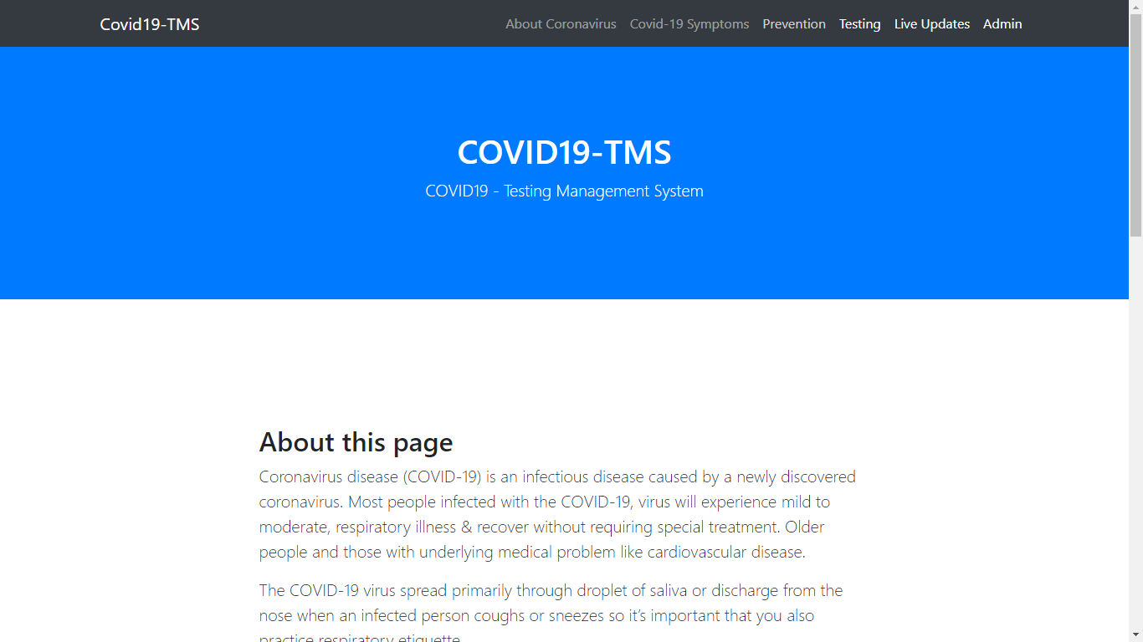

Testing for Covid-19

### Screenshot (452).png

User Dashboard after login showing all the information

### Screenshot (455).png

### Order for testing of particular user

### Screenshot (456).png

### Test Details

### Screenshot (457).png

### Test Tracking history

### Screenshot (458).png

### Admin DashboardScreenshot (459).png

### Admin Report DownloadScreenshot (460).png

### Admin Managing all PhlebotomistScreenshot (461).png

### Admin adding PhlebotomistScreenshot (462).png

### All Tests Tracking-Screenshot (463).png

### Notification window-Screenshot (465).png

### Admin ProfileScreenshot (466).png

**Conclusion**

Implementation of Covid test management project helps to store all the kinds of records ,help people to get vaccinated and get their report easily.